Appendix 1
20/03083/FUL 113 Normandy Crescent
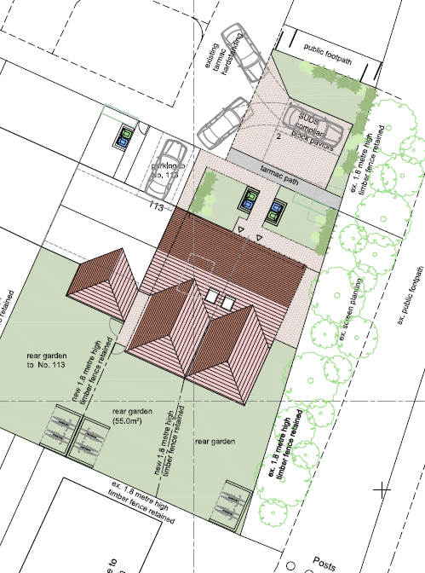
Proposed block plan

